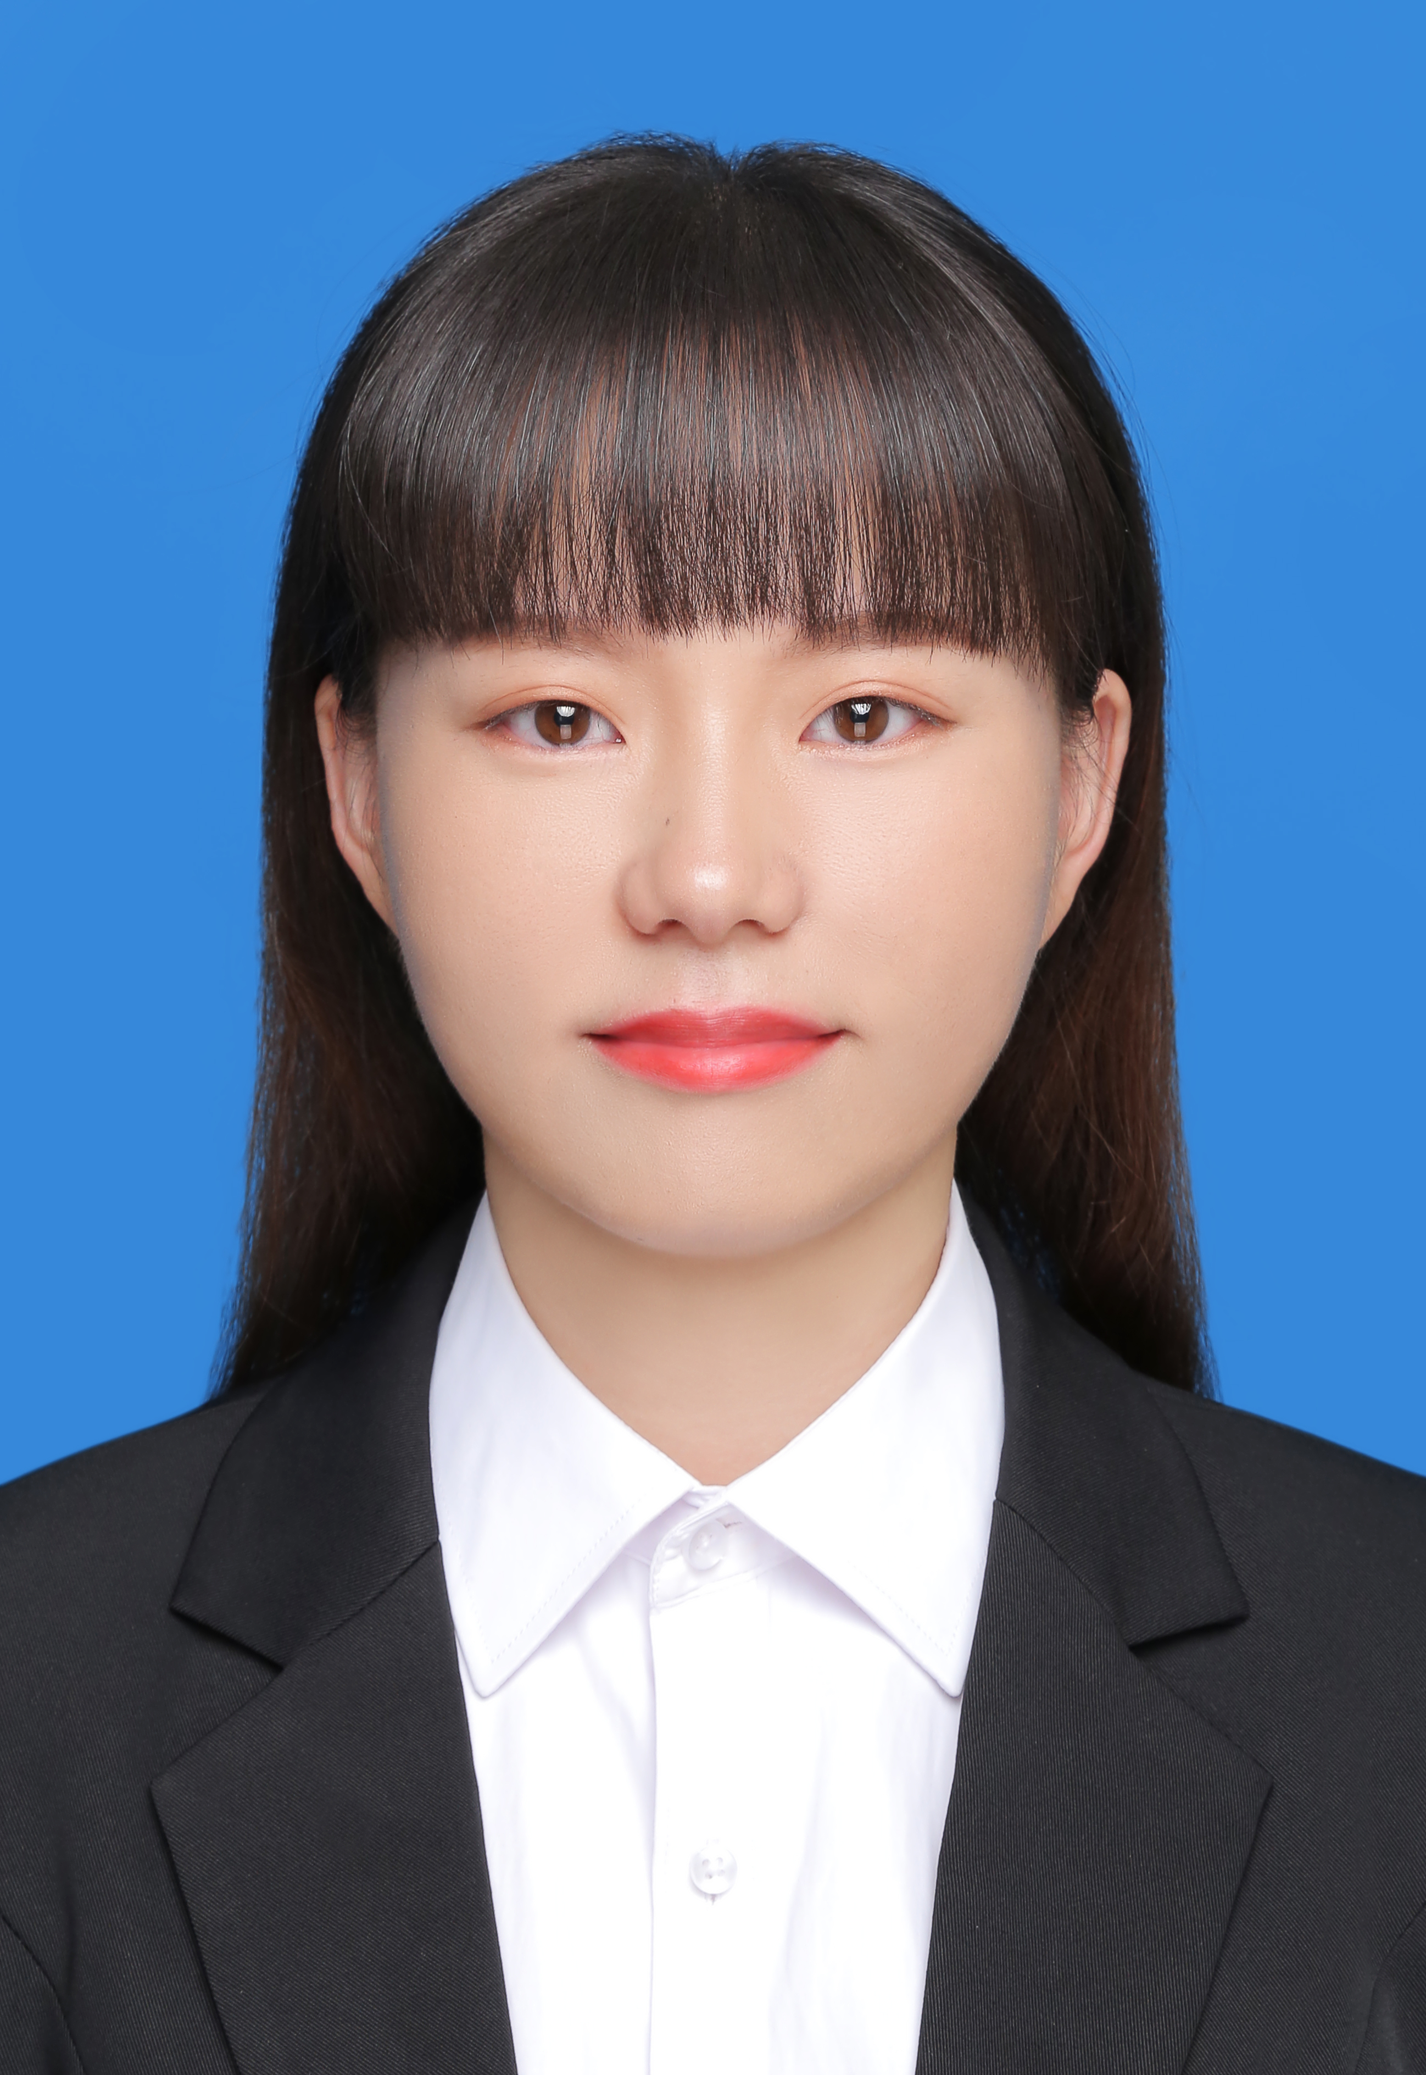resume

* **Basic Information**

Name: Jiang Guoxia Gender: Female Date of Birth: 1991/08

Political Aspect: Party Member Birthplace: Xiaogan City, Hubei Province

Tel: 15201116386 Email: jiangguoxia@ucas.ac.cn

* **Educational experience**
* **2015/09 — 2020/6: direct blog**

Eco-Environmental Research Center, Chinese Academy of Sciences Major: Environmental Engineering

Supervisor: Researcher Hao Zhengping

* **2011/09 — 2015/06: Bachelor of Science**

Resources and Environmental Science Major: Environmental Science

Wuhan University

* **research direction**
* **Green Catalysis and Environmental Materials:** Decomposition hydrogen production, water gas conversion, selective oxidation (reduction ) , nanoporous materials .
* **Environmental analysis and policy research:** characteristics of volatile organic compounds, acid gases, and greenhouse gas emissions; G C-MS and LC -MS/MS analysis, industrial pollution reduction and control .
* **work experience**
* **2020 / 11 —present : Research Center for Environmental Materials and Pollution Control Technology, University of Chinese Academy of Sciences/National Engineering Laboratory for Volatile Organic Compound Pollution Control Materials and Technology, Special Research Assistant**
* **Article publication and project participation**

Presided over a project of the National Natural Science Foundation of China for Young Scholars ( 22106162) , and participated in key and general projects of the National Natural Science Foundation of China ( 21337003 , 21507148 , 21577158 , 21976176) . At present, he has published more than 20 articles in international famous journals such as P NAS , ACS Catalysis, Appl. Catal . B, Chem. Eng. J, Carbon , J. Hazard. Mater. , applied for 11 national invention patents , and participated in environmental chemistry Writing relevant chapters of the book Frontiers and Prospects of the Subject (Science Press).

# Main scientific research achievements

1. **Jiang G.**, Zhang X., Zhang F., et al. Efficient recovery of hydrogen and sulfur resources over non-sulfide based LaFexAl12-xO19 hexaaluminate catalysts by H2S catalytic decomposition[J]. **Applied Catalysis B: Environmental**, 2020, 263: 118354.
2. **Jiang G.**, Zhang F., Wei Z., et al. Selective catalytic oxidation of ammonia over LaMAl11O19-δ (M = Fe, Cu, Co and Mn) hexaaluminates catalysts at high temperature in Claus process[J]. **Catalysis Science & Technology**, 2020, 10(5): 1477-1491.
3. Wei Z., Zhao M., Yang, Z., Duan X., **Jiang G.\***, et al. Oxygen vacancy-engineered titanium-based perovskite for boosting H2O activation and lower-temperature hydrolysis of organic sulfur[J]. **Proceedings of the National Academy of Sciences**, 2023, 120(3), e2217148120.
4. Li, G., Shui, Z., Duan X., Yang, H., Zhao, Z., Zhao, T., Zhang, Z., **Jiang, G.\***, et al. Unveiling the balance between catalytic activity and water resistance over Co3O4 catalysts for propane oxidation: The role of crystal facet and oxygen vacancy[J]. **ACS Catalysis**, 2023, 13(1), pp. 237-247.
5. Yang, H., Li, G., **Jiang, G.\***, et al. Heterogeneous selective oxidation over supported metal catalysts: From nanoparticles to single atoms[J]. **Applied Catalysis B: Environmental**, 2023, 325, 122384.
6. Zhang F., Wei Z., **Jiang G.\***, et al. Synergistic conversion of acid gases (H2S and CO2) to valuable chemicals: Carbonyl sulfide synthesis over vacancy-defective CoMo sulfide catalysts[J]. **Applied Catalysis B: Environmental**, 2022, 319, 121912.
7. Duan X., Zhao T., **Jiang G.**, et al. High-temperature catalytic oxidation of 1,2-dichlorethane: An alternative applicable method for safe elimination of CVOCs[J]. **ACS ES&T Engineering**, 2022, 2(7), pp. 1260–1273.
8. Li G., He K., Zhang F., **Jiang G.**, et al. Defect enhanced CoMnNiOx catalysts derived from spent ternary lithium-ion batteries for low-temperature propane oxidation[J]. **Applied Catalysis B: Environmental**, 2022, 309, 121231.
9. Zhang F., Zhang X., **Jiang G.**, et al. H2S selective catalytic oxidation over Ce substituted La1-xCexFeO3 perovskite oxides catalyst[J]. **Chemical Engineering Journal**, 2018, 348: 831-839.
10. Zhang F., Zhang X., Hao Z., **Jiang G.** , et al. Insight into the H 2 S selective catalytic oxidation performance on well-mixed Ce-containing rare earth catalysts derived from MgAlCe layered double **hydroxides** [J]. **of Hazardous Materials,** 2018, 342: 749-757.
11. Hao Zhengping, **Jiang Guoxia** , etc. Pyrochlore composite material and its preparation method and application, **Chinese invention patent** C N114950451A
12. Zhang Xin , **Jiang Guoxia ,** Hao Zhengping , A method for catalytic combustion of H 2 S acid gas in the Claus process , **Chinese invention patent** CN109114577A
13. Zhang Fenglian, Hao Zhengping, **Jiang Guoxia** , etc. Catalyst for synthesizing methyl mercaptan with carbon dioxide, hydrogen sulfide and hydrogen, its preparation method and application, **Chinese invention patent** CN114308080A
14. Hao Zhengping , Zhang Xin , **Jiang Guoxia , etc.,** Application of hexaaluminate composite oxide materials in H 2 S catalytic decomposition reaction , **Chinese invention patent** CN109012144A
15. Zhang Xin , Hao Zhengping , Zhang Fenglian , **Jiang Guoxia , Application of** hydrotalcite-like molybdenum-based composite sulfide catalytic materials in the synergistic catalytic conversion of H 2 S and CO 2 to carbonyl sulfide , **Chinese invention patent** CN109046390A